Basically one must distinguish between two kinds of porosities:  
• Total porosity (isolated pores are considered also) and  
• Effective porosity (effective in the sense of fluid transport).  
The storage capacity of a reservoir rock always depends on the effective porosity, since it contains the reservoir fluids.

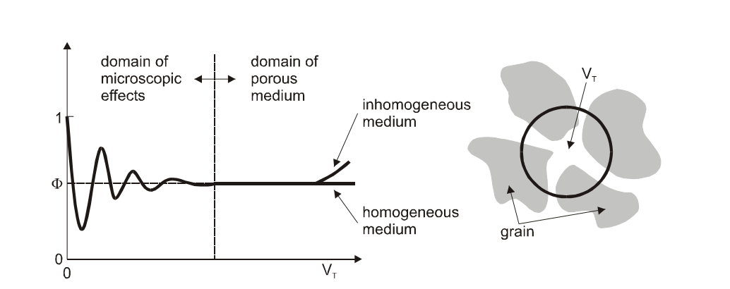

**Fig l.** Definition of representative control volume for porosity measurements

Porosity is a statistical quantity that depends on the magnitude of the total volume taken into consideration (see Fig.1). If the selected volume is too small (e.g.: VT = 10-9m3) the calculated porosity can deviate greatly from the true value, therefore the volume VT should be large enough in order to obtain the statistical average of porosity.  
On the other side if the volume is too large the porosity may deviate from the real value due to the influence of heterogeneity

**Determination of Porosity**The determination of the porosity with sufficient accuracy is not a trivial issue, especially  
for small samples. If the errors in measuring VT and VP are ▲VT and ▲VP then Eq. 2  
will lead to :

$\frac{∆∅}{∅}=\frac{∆V_{p}}{V_{p}}+\frac{∆V_{T}}{V_{T}}$ (3)

Where $∆∅$ is the error in calculating the porosity.

Assuming that $∆V_{p}$ = $∆V_{T}$ eq. 3 can be written as:

$\frac{∆∅}{∅}=\frac{∆V}{V_{T}}(1+\frac{1}{∅})$ (4)

According to Eq. 1.4, the relative error of the porosity measurement depends on VT and Ø Assuming an error V=10-9 m3 for the values of V, this error can be up to 50% as shown in Table 1.

Table 1: Relative errors in measuring porosity( VT=+(-)10-9 m3

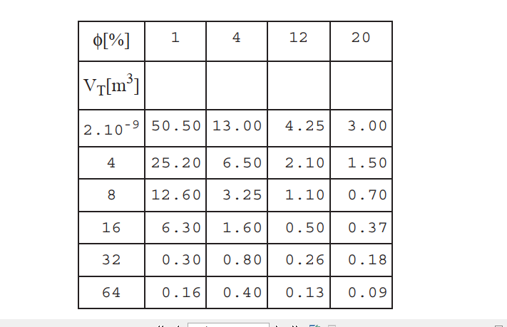

The following quantities are necessary in order to calculate the porosity based on Eq. 2:  
• the total volume (VT),  
• the solid volume (Vs),  
• the void volume (Vp).

Example 1:  
A core plug has a radius of 1.25*10-2 [m] and a length of 5.0*10-2 [m]. It is completely saturated with brine having a density of 1200 [kg/m3]. The dry core plug weighed 5.1*10-3 [kg], and 10.4*10-3 [kg] when it was saturated with brine. Calculate the effective porosity of the core plug.

Weight of brine in the plug w

$$w=10.4×{10}^{-3}-5.1×{10}^{-3}={5.3×10}^{-3} kg$$

The volume of brine (pore volume) Vp

$$V_{p}=\frac{w}{ρ_{w}}=\frac{{5.3×10}^{-3}}{{1.2×10}^{3}}={4.42×10}^{-6} m^{3}$$

$$Bulk volume of plug V_{T}=r^{2}πh={24.5×10}^{-6} m^{3}$$

$$Porosity of plug ∅=\frac{V_{p}}{V_{T}}=18\%$$

**Compaction**Figure 2 shows porous media built with spheres of equal size. The spheres are arranged in three different ways to illustrate the effect of compaction on the porosity of a pack. However, no characteristic factor has been introduced yet to describe compaction as a property.  
The compaction - and thus porosity - of sediment depends on the greatest depth a rock reached during its genesis. Figure 3 shows the porosity of clay and sandstone as a function of depth. The compaction - in contrast to the compressibility - is irreversible.

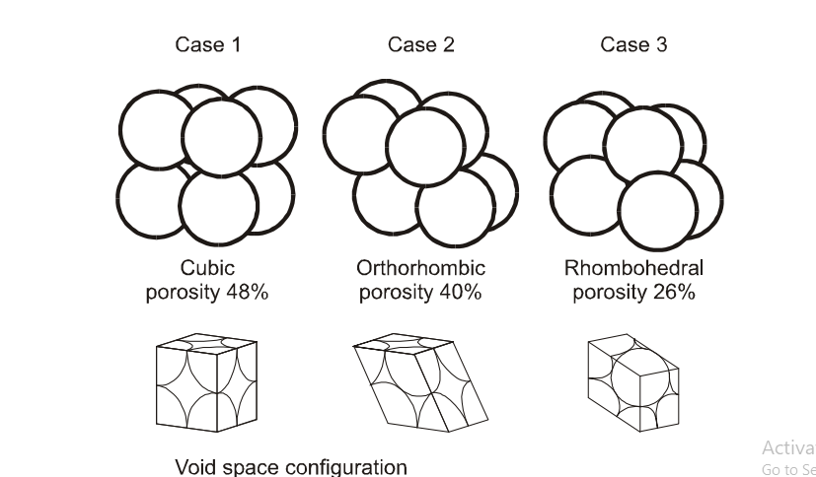

Fig. 2 Packing of spheres and porosity

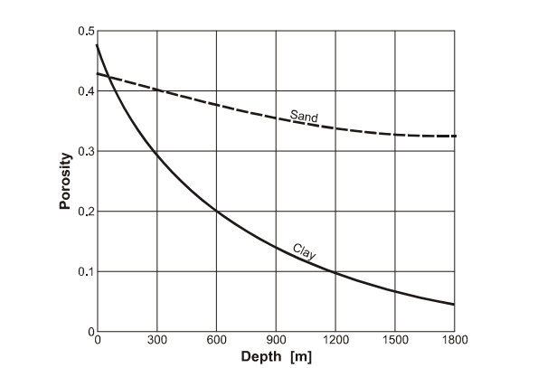

Fig.3 Sediment compaction and porosity

**Compressibility of Porous Media**Reservoir rock is not considered to be a rigid system but as a - only minor though – elastic and thus compressible medium. The change of pressure inside the pore space during the production also affects the porosity. The isothermal compressibility of porosity is defined as:

$c_{∅}=\frac{1}{∅}{(\frac{∂∅}{∂P})}_{T}$ (5)

Integration of the preceding equation leads to:

$∅=∅_{0}e^{{c_{∅}}_{(p-p_{})}}=∅_{0}[1+c_{∅}\left(P-p_{0}\right)]$ (6)

where Ø0 is the porosity at the pressure *p*0

However, cØ is small and normally regarded as a constant. The pore volume alteration during the pressure drop in the reservoir has its source in the elasticity of the solid.  
Therefore cØ will be a function of porosity. Figure 4 illustrates this relationship.

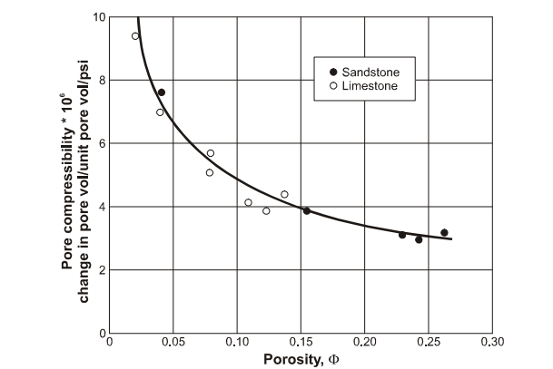

Figure 4 Pore compressibilities of rocks

The compressibility of the pore space is influenced by overburden pressure too, which is illustrated in Figure 5

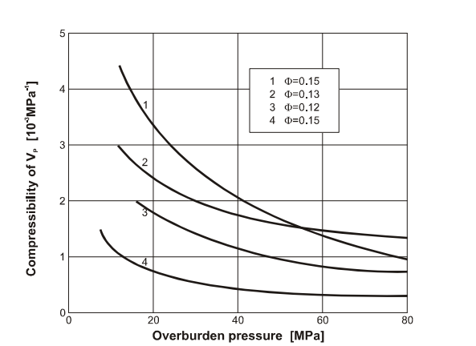

Figure 5 Pore volume compressibility factor in terms of overburden pressure

**Classification of Porosity**

Porosity can be classified as primary or secondary. Primary porosity forms during the deposition of sediments and include interparticle and intraparticle porosities. Secondary porosity forms after deposition and develops during diagenesis by dissolution, dolomitization and the production of fractures in the rock. Intergranular porosity (also interparticle porosity) is formed between grains during deposition and is the amount of pore space between grains or particles. Intraparticle porosity occurs within individual particles or grains. It is abundant in carbonate sediments and can be an important part of the preserved porosity in carbonate rocks. Internal chambers or other openings within an individual or colonial skeletal organisms are the most commonly recognized form of intraparticle pores.  
One can distinguish between fabric and non-fabric selective porosity. Fabric selective porosity includes primary (interparticle and intraparticle porosity) and secondary (e.g. intercrystalline or moldic porosity). Secondary non-fabric selective porosity includes vuggy porosity and fracture porosity. Intercrystalline porosity occurs between crystals of similar size and is restricted to crystals that have grown in place, for example, dolomites, evaporates, and recrystallized carbonates. The sizes of pores are generally controlled by the size of crystals.  
Intercrystalline porosity may either be primary or secondary in origin.  
Vuggy porosity is a non-fabric selective porosity caused by the selective removal (solution) of grains in a rock. Depending on the extent of the solution, the resulting pores are classified as molds, solution-enlarged molds, or vugs. Recovery efficiency in reservoirs with melodic porosity is strongly controlled by the size and number of connections between the molds.  
Fracture porosity generally refers to porosity that occurs along breaks in a sediment or rock body where there has been little mutual displacement along the fracture. Natural fractures occur in all subsurface formations. Fracture porosity grades into breccia porosity with increasing dislocation. In carbonate rocks, fracture porosity may originate from collapse related to solution, slumping, or tectonic deformation. Fractures can be observed on cores, and can be characterized as filled, semi-filled and open fractures. Filled fractures do not contribute to the porosity. The fractures are described by their orientation as horizontal, vertical or oblique fractures.

**Soil - Water Characteristic Curve  
*Concept of Soil Suction***It was demonstrated with an example problem earlier that negative pressure develops in the capillary water when the capillary diameter is very small. The pore water pressure in most of the fine-grained soils, that have very small pore sizes, is negative when the water content is less than its full saturation. Surface tension mechanism can’t play a role in fully saturated soils due to the absence of an air-water interface and, thus, pore water pressures are positive in such soils.  
Soil suction can be defined from a thermodynamics point of view as the thermodynamic potential of soil pore water relative to the free water potential. Free water in this regard is defined in many texts books as water containing no dissolved solutes, having no interactions with other phases that impart curvature to the air-water interface, and having no external forces other than gravity. The thermodynamic potential of soil pore water may well be described in terms of the  
chemical potential, μ . The chemical potential of the soil pore water represents the amount of energy stored per unit mass of pore water (Joules/mol). The mechanisms responsible for total soil suction are those that decrease the potential of the pore water relative to this reference state.  
The primary mechanisms that decrease the potential of soil pore water are capillary effects, short-range adsorption effects between particle-pore water, and osmotic effects while other effects such as temperature, gravity, and inertial effects are neglected. The capillary mechanism is unique to unsaturated soils. On the other hand, both the adsorption and osmotic mechanisms can occur under any degree of saturation. Capillary effects and the associated negative pore water pressures due to curvature of the air-water interface in the three-phase unsaturated soil system are well described above.  
Adsorption of water molecules is primarily due to the electrical and van der Waals forces occurring within the vicinity of the solid–water interface in the soil pore space of the fine-grained soils. Clay surfaces carry net negative charge due to isomorphous substitution which results in electrical forces at the particle level. On the other hand, short-range van der Waals forces arise from atomic scale interactions between the molecules of the clay surfaces and molecules of the pore water. The van der Waals forces exist in all soils. However, the effect is more pronounced in clays due to significant net surface charge and relatively large surface area.  
The effect of these two forces decays rapidly with distance from the particle surface. Moreover, the short-range adsorption effects are more pronounced at a relatively low degree of saturation, in which the adsorbed pore water is primarily in the form of thin films coated around the particle surfaces.  
Osmotic suction is due to the dissolved solutes in the pore water. The dissolved solutes/salts reduce the chemical potential of the pore water below the free water potential. The presence of dissolved solutes in the soil pores is either due to an external source (e.g., chemical diffusion through soils) or naturally occurring exchangeable cations on the clay surface.

***Suction arising from the combined effects of capillarity and short-range adsorption is usually grouped under the more general term matric suction,*** ψ***m*** . It reflects the pore water and the soil solids/soil matrix. Suction arising from the presence of dissolved solutes is referred to as osmotic suction, ψo . Total soil suction, ψt is generally considered the sum of matric and osmotic suctions as given follows:

ψt = ψm + ψo -------- (3)

Similarly the total decrease in pore water chemical potential, Δμt , due to these factors can be described in terms of energy state as:  
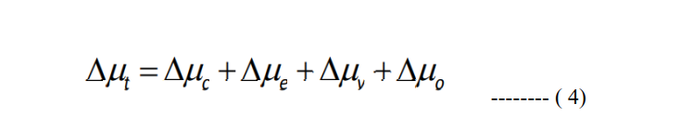

where Δμc is the change in chemical potential due to capillary effects, Δμe is the changes due to the existence of electrical fields (ex: clays), Δμv is the changes due to van der Waals fields, and Δμo is the changes due to osmotic effects. Each term on the right-hand side of eq. (4) is a negative value. The negative value expresses the decrease in chemical potential from the reference potential due to each factor described by the subscript. However, the soil suction is expressed as a positive value, because it describes the decrease in potential relative to a reference potential.  
***Suction vs. water content***Commonly known mechanisms that change the saturation levels of the soils, in nature, are evaporation, rainfall infiltration, changes in the groundwater table, and disturbances due to human activity. The effect of water retention and many mechanisms can conveniently be explained by considering simple capillary tube models. The influence of evaporation on the fully saturated soil mass can be understood by conveniently approximating the network of capillaries across the pore spaces of soils with a system of capillary tubes as illustrated in Fig. 5-  
6. The evaporation from a single thin capillary is considered and is illustrated in Fig. 5. At the beginning, the capillary is completely filled with water and the water content is as shown in the figure. Assuming that the air-water interface initially is nearly flat and the gauge water pressure is, therefore, zero in the tube. The amount of water within the tube decreases with time as the evaporation progresses. However, the water is initially removed without the loss of interaction between the air-water-solid interfaces. Surface water at the edges of the capillary tube. This compels the formation of the meniscus and, thus, the changes in the air-water interface. With the additional loss of water from the tube due to evaporation, the meniscus curvature increases, and the gauge water pressure in the tube drop to negative values as indicated in Stage#2 of the figure. The water pressure, in Stage#3, decreases to such an extent that the contact angle is equal to the receding angle, θ***ra*** , which is the maximum negative pressure sustained by the surface tension forces at the air-water interface. The water pressure corresponding to this stage is called ***air-entry pressure,*** ψ ***a***. Any further evaporation at this stage causes a lowering of the water level in the capillary tube with the contact angle remaining equal to the receding angle and negative pressure at the interface equal to the minimum sustainable value as depicted in Stage#4.  
The relation between water content and negative pressure in the tube during these stages is also shown in Fig. 5. It is important to note that the degree of saturation remains 100% until Stage#3 albeit the water content is less than.

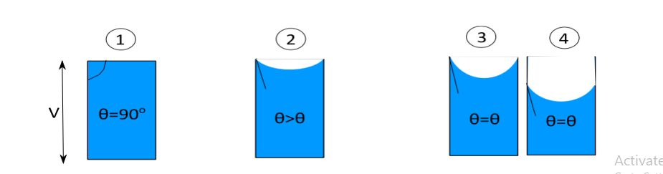

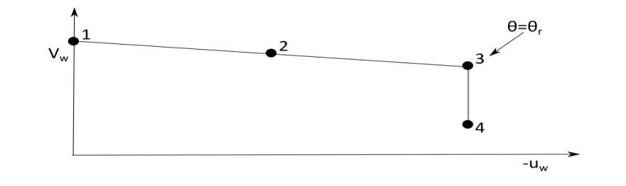

The water retention behavior in a negatively charged capillary tube will be similar to the one described in Fig. 5. However, the decrease in the volume of water with suction will be smaller when compared to the earlier case. The tube will achieve a steeper receding angle than the previous case and requires more suction to lose the same amount of water. Thus, clays generally have more retention capabilities for water due to the combined effects of capillary and adsorption forces when compared to sands. However, the pore structure in the clays can better be  
represented more realistically as shown in Fig. 6.

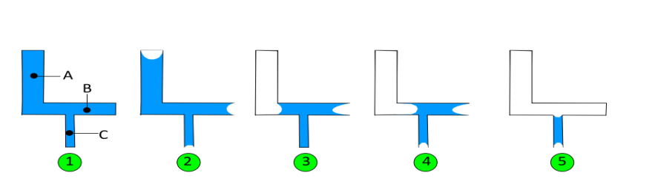

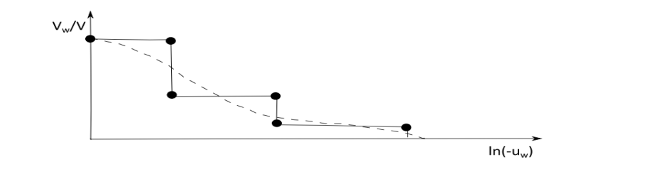

Fig. 6. Illustrative experiment of evaporation from a well-connected and negatively charged capillary system The assumed system in Fig. 6 is formed by three horizontal capillary tubes, A, B, and C, respectively having the same length, L, and diameters of the tube are dA = 2dB, dB = 2dC. Water evaporation takes place in this system as in the earlier case, albeit the evaporation loss is different in different tubes. Since the diameters of tubes A, B, and C are in descending order, the contact angles will be in ascending order in the tubes and, thus, the limit receding angle, θra, will therefore be reached in the larger tube first. The larger tube will empty at constant pressure at this stage, which is the minimum pressure sustainable for this tube. The remaining tubes are still saturated and, as evaporation proceeds, the curvature of the menisci is increased until the limit contact angle is reached in tubes B and C. Further evaporation will eventually empty the water into smaller tubes. The relationship between the degree of saturation and evaporation pressure or negative pore pressure in the capillary system is shown in Fig. 6. The interconnecting pore structure of the natural soils can be approximated with an infinite number of capillary tubes of different sizes as given in the capillary system, Fig. 6. Consequently, the relation between the degree of saturation of the soil and negative pore water pressure follows the same trend as described here. Such a relationship, commonly obtained from experiments in unsaturated geomaterials, is referred to as water retention curve or soil water characteristic curve.  
The retention curve is of fundamental importance in unsaturated soil mechanics for  
understanding the volume change, strength, and hydraulic characteristics of unsaturated soils.  
As the surface of the soil desiccates, the soil becomes unsaturated and ***matric suctions*** develop. The relationship between moisture state (expressed in terms of the volumetric water content, ***θw*** = volume of water/total volume, as a decimal; *w* = mass of water/mass of solids, as a percentage; or degree of saturation, *S* = volume of water/volume of voids, as a percentage) and matric suction**, *ua- uw***, (to a logarithmic scale) is termed the *soil water characteristic curve* (SWCC). Typical soil-water characteristic curves for sandy, silty, and clayey soils are illustrated in Figure 7a. Important parameters of the soil-water characteristic curve are indicated  
in Figure 7b. There are many equations suggested for the soil-water characteristic curve [7].  
However, it was found that the following equation by [8] gave the best fit to the soil-water characteristic data:

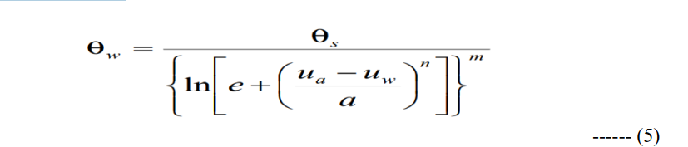

where : **θw** = volumetric water content, **θs** = saturated volumetric water content, **e** = natural base of logarithms, (**ua – uw**) = matric suction, **ua** = pore-air pressure, **uw** = pore-water pressure, **a**, **n** and **m** = constants.  
The method of determining the soil-water characteristic curve for coarse or medium-textured soils and fine-textured soils can be found in **ASTM D2325-68** and **ASTM D3152-72**, respectively. These tests allow soil-water characteristic curves of up to 1520 kPa matric suction to be developed. Other methods such as the salt solution method [10] can be used to develop the soil-water characteristic curve for the higher suction range. The key elements of the SWCC are the following:  
• The break in the curve at high degrees of saturation or high water content, referred to as the air-entry value, ***AEV***, at which the material is unable to remain saturated at the applied matric suction; the capillary rise in meters is equal to AEV/9.81 The slope of the curve at matric suctions is higher than the AEV; the flatter the curve the more water the material is able to “store”  
• The residual saturation or water content, to which the material will potentially drain

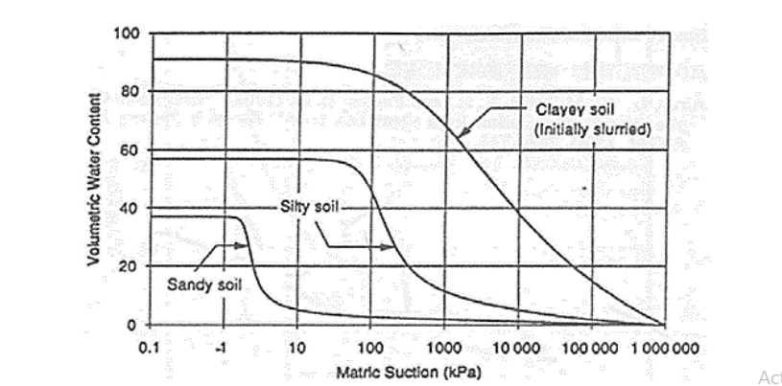

**A**

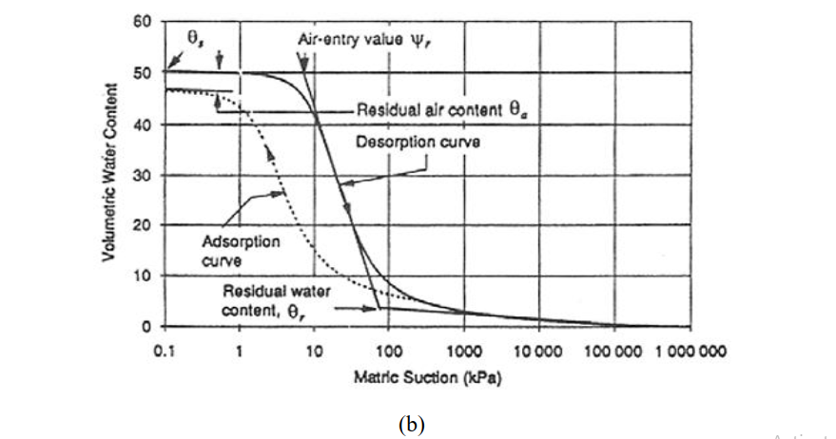

Fig. 6. Typical SWCCs.

**Water retention mechanism in soils**

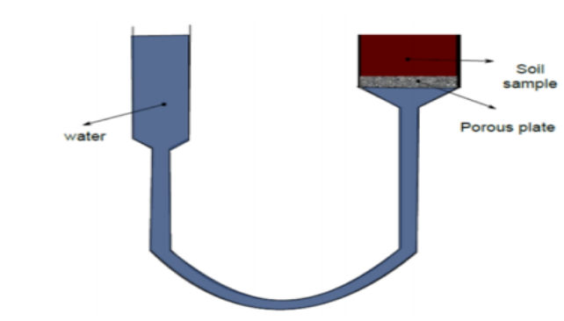

Fig. 7. Conceptual illustration of soil water retension

Consider a soil sample in contact with porous stone that allows only the water movement into and out of the soil. The soil is connected to a flexible burette filled with water. The water level in the burette, at the beginning of the experiment, is at the same level as the saturated soil surface as shown in Fig. 7. When the soil surface is raised from the previous level, the soil is still saturated due to capillary rise of water in the soil pores against the gravity. The soil starts to desaturate when the level of the soil is increased due to drainage of the pore water under gravitational force. However, the soil still holds some water in the pores due to osmotic and adsorption mechanisms. The relative contribution of these two mechanisms responsible for soil water retention in soils is discussed here, in detail. The dominant pore water retention mechanism at relatively high values of water content or very low values of suction is becomes capillarity. This is governed primarily by pore size distribution in the soils. At low values of  
water content and correspondingly high values of suction, the osmotic mechanism plays an important role in retaining the water.

***Osmotic mechanism***It is well known that the surface of the clay particles is negatively charged due to isomorphous substitution. Several cations are present in the diffuse double layer around the clay surface, in an exchangeable state, due to the negative charge. The concentration of these exchangeable cations at the surface of the interacting particles is higher as compared to that in the solution. This concentration difference drives the water molecules to diffuse toward the interlayer in an attempt to equalize concentration. This mechanism of water retention in clayey soils is referred  
to as an osmotic mechanism.  
***Adsorption mechanism***At very low values of water content, the pore water is primarily in the form of thin films on the particle surfaces. The dominant mechanism contributing to negative pore water pressure (suction) is the electrostatic forces at the clay particle surface. Water molecules are strongly held on the particle surfaces due to these forces. They are also retained by the hydration of exchangeable cations. Consequently, capillary mechanisms play a role at a relatively high degree of saturation, where  
as osmotic and electrostatic mechanisms become relevant at medium to low degrees of saturation. All these mechanisms are invoked due to the interaction of air and water phase with solid phase; and are, thus, associated with the soil matrix”. This is the reason why suction generated by these mechanisms is referred to as “matrix suction” or “matric suction”. The water retention curve (WRC) describes the corresponding constitutive relationship between soil matric suction and water content. The general shape of the SWCC of a given soil reflects the  
influence of several material properties, such as pore size distribution, grain size distribution, density, organic material content, clay content, and mineralogy on the pore water retention behavior (Lu and Likos, 2004). The general shape of WRC is given in Fig. 8.

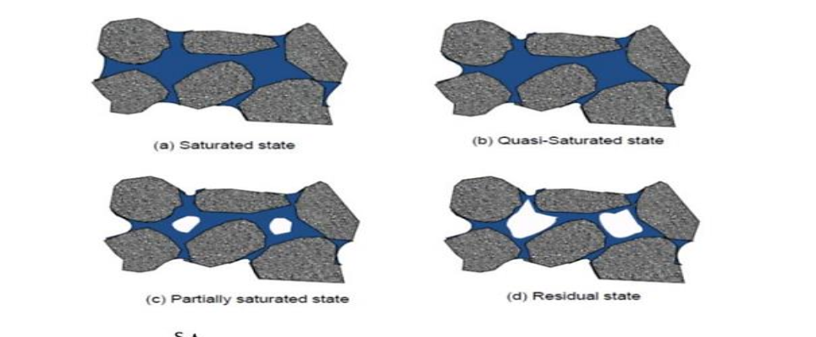

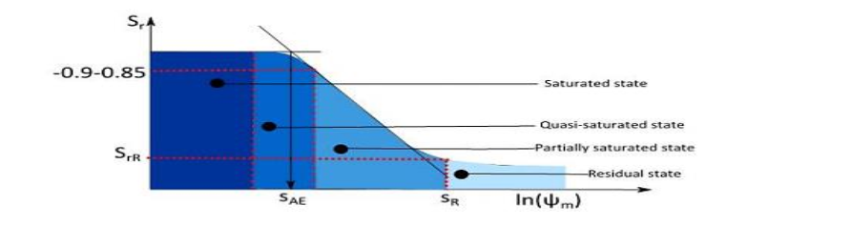

Fig. 8. Soil water renetion curve

The WRC is often plotted on a semilog plot of suction against moisture content as shown in Fig. 8. The curve can be approximated with three distinct line segments having different slopes, with a degree of saturation ranging from zero to one, as illustrated in the figure. These segments illustrate four different stages of moisture regimes in the soil with increasing matric suction from zero value at the saturated moisture content. The soil is fully saturated in the first moisture regime where the moisture loss is due to a change in the shape of the meniscus. The thickness of  
this regime depends on the surface properties of the soils that can influence the receding contact angle. The contact angle reaches the receding angle at the end of this regime. As the suction increases, the soil enters the quasi-saturated regime where the moisture is lost by keeping a constant receding angle. The air enters the largest pore of the soil in this regime. Once the air entry value is reached, the retention curve enters a regime dominated by capillary pore water retention mechanisms. The soil looses the water at a faster rate with an increase in the suction in this regime. The amount of water retained here is a function of the particle and pore size properties. An additional increase in suction would bring into a residual state where the loss of water is very less for the increase in the suction. The amount of water retained at this stage is a function of the surface area of the soil particles, the surface charge density of the soil mineral, and the type and valency of any adsorbed exchangeable cations. Within the adsorbed film segment, water is retained in the form of thin films on the particle surfaces under the influences of short-range electrical forces, van der Waals attraction, and exchangeable cation hydration. Water molecules are strongly held on the particle surfaces due to electrostatic forces at this stage. In clays greater amount of pore water is required to satisfy the relatively large surface hydration energies associated with the high suction regime. Thus the residual regime extends to very large suction values. On the other hand, in sands, very little water is adsorbed under initial surface hydration mechanisms. However, the capillary effects dominate over the majority of the unsaturated water content range in sands.  
**SHEAR STRENGTH**The past two decades have seen a rapid development of unsaturated soil mechanics with the identification of the two stress state variables, matric suction (ua-uw) and net normal stress (σ- ua), governing unsaturated soil behavior. It can be easily illustrated using these stress state variables that unsaturated soil mechanics is more general and encompasses all the principles of saturated soil mechanics. For example, the commonly used Mohr-Coulomb shear strength criterion in practice can be extended for unsaturated soil:



Where: **τ** = shear strength, **c'** = effective cohesion, **φ**' = effective angle of friction, and **φb** = angle describing the change in shear strength due to change in matric suction. The representation of Equation 6 is given in Figure 9. As the soil becomes saturated, **uw** approaches **ua** and Equation 6 becomes:

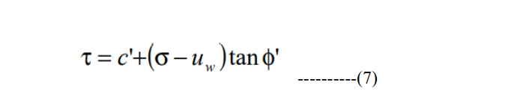

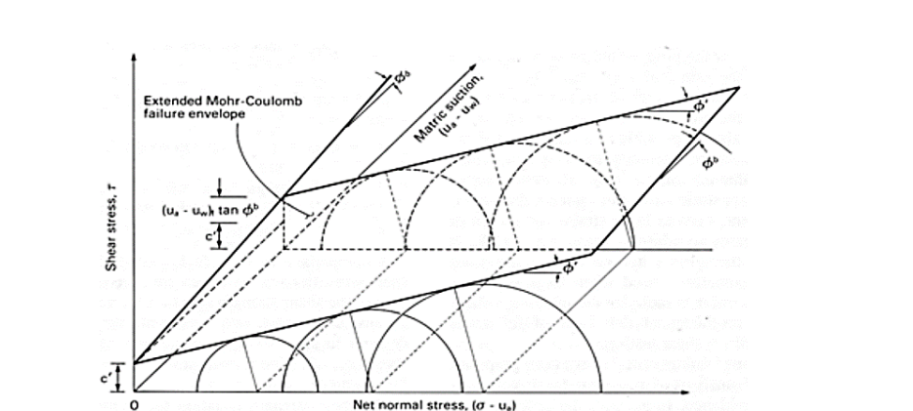

Fig. 9. Extended Mohr-Coulomb criterion for unsaturated soil

As illustrated in Equation 6 and Figure 9, the shear strength of unsaturated soil can be represented by an extended Mohr-Coulomb criterion. It has been proposed that the shear strength of unsaturated soil can be obtained from the saturated soil shear strength parameters and the soil-water characteristic curve. In this context, it is useful to use the concept of a fourth phase in unsaturated soil. The stress state variables, (σ - ua) and (ua – uw), are the surface tractions controlling the soil structure and contractile skin. Therefore, the contribution of matric suction to shear strength can be represented by an increase in contact surface given by the normalized area of water, **aw** [12]. The normalized area of water aw is defined as:

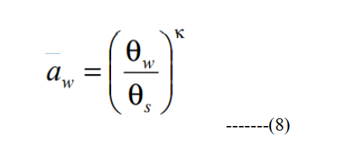

where κ = fitting parameter. The increase in shear strength due to matric suction as given by tan φb can then be treated as equal to (aw tan φ’) and therefore, Equation 1 can be rewritten as:

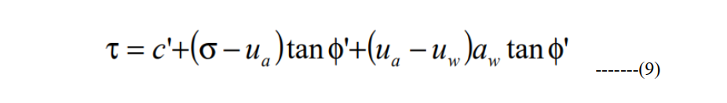

**Definition of air-entry value**For soils A and B, the soil water retention curves and K (-curves are given below.  
What is the difference between the two soils? Draw also the approximate K (h-curve for  
soil B.

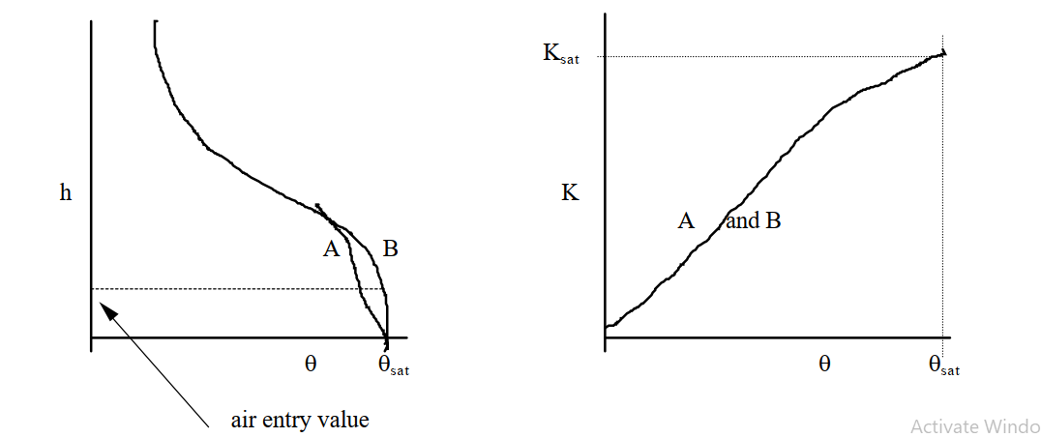

The air entry value of a specific soil is determined by the radius of the largest pore. If this largest pore is relatively small, the air entry value will be relatively large.

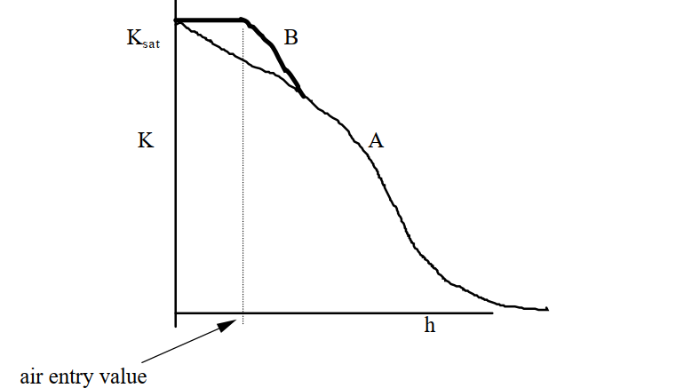

Sometimes one uses bubbling pressure to denote air entry value. Remember that simple averaging of K will not work in a column with large H, because K is not constant with X, and consequently  H/X is nonlinear with X **(we will get back to this later).**

**Soil-water pressure head distributions for steady state flow in unsaturated soils:**

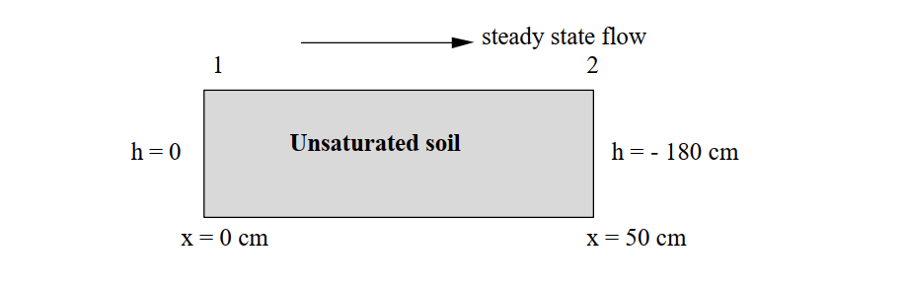

Problem: How does the soil-water pressure head vary with x?  
NOTE: Both h and K(h) changes greatly with x inside the column.

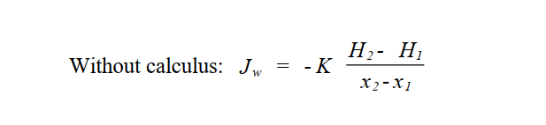

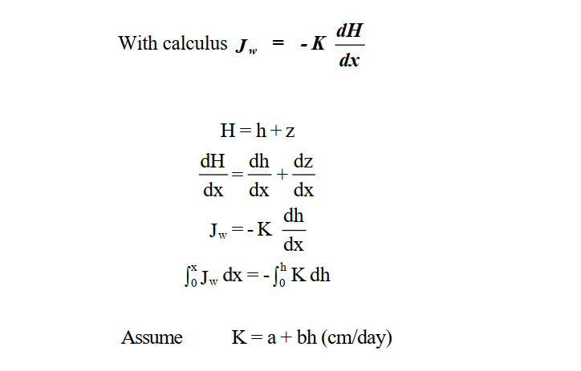

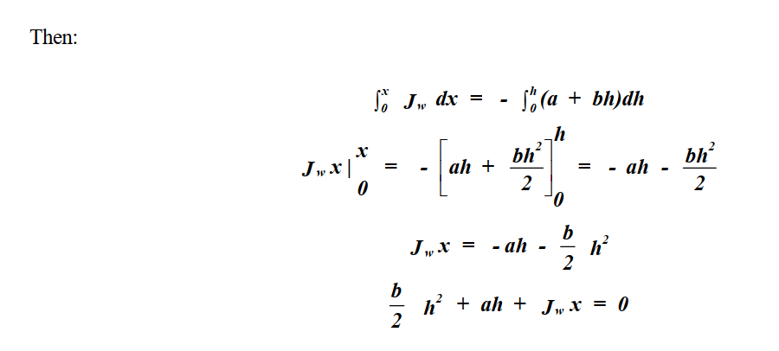 This is a quadratic equation, which can be easily solved for h:  
How is the following solution obtained ?

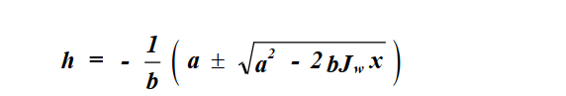

The solution has both a positive and negative root. Which one can only be used?  
At x=0, h = 0, so we can only use the negative root:

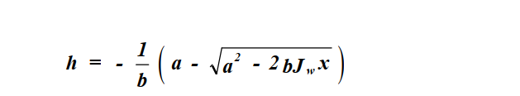

This solution yields ha a function of distance x, or h = f(x). However, we must first know Jw. This can be determined if K as a function of h is known. Let a = 4, b = 0.02. Then use previously found relationship.



Let a = 4, b = 0.02.

Example : Draw the change of h with x=0,10,20,30,…..,50, A similar derivation can be written for the **vertical case** (with identical boundary conditions):  
Assume again that K = a + bh (with a=4 and b=0.02), and solve for Jw and h(z):

